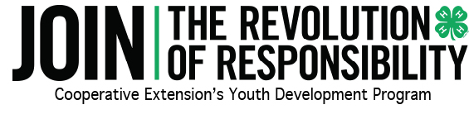

Requirements for 4-H Electric Congress 4-H Portfolio (former Cumulative Record) Delegates
- A 4-H’er who completes an Electric Portfolio is not guaranteed a trip to NC 4-H Electric Congress.
- Portfolio Electric Congress Delegates are selected based on the quality and content of their portfolio by a trained selection committee.
- All books are expected to meet the State Office format requirements.
Selection Criteria
- Knowledge and skills gained while participating in the 4-H Electric Project
- Exhibit an increase in knowledge each year
- 4-H experiences in Leadership, Citizenship & Community Service
- Sharing the 4-H Electric program with others (includes teaching or assisting with electric project activities)

