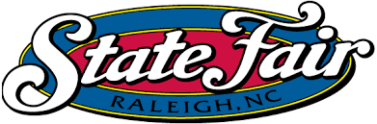
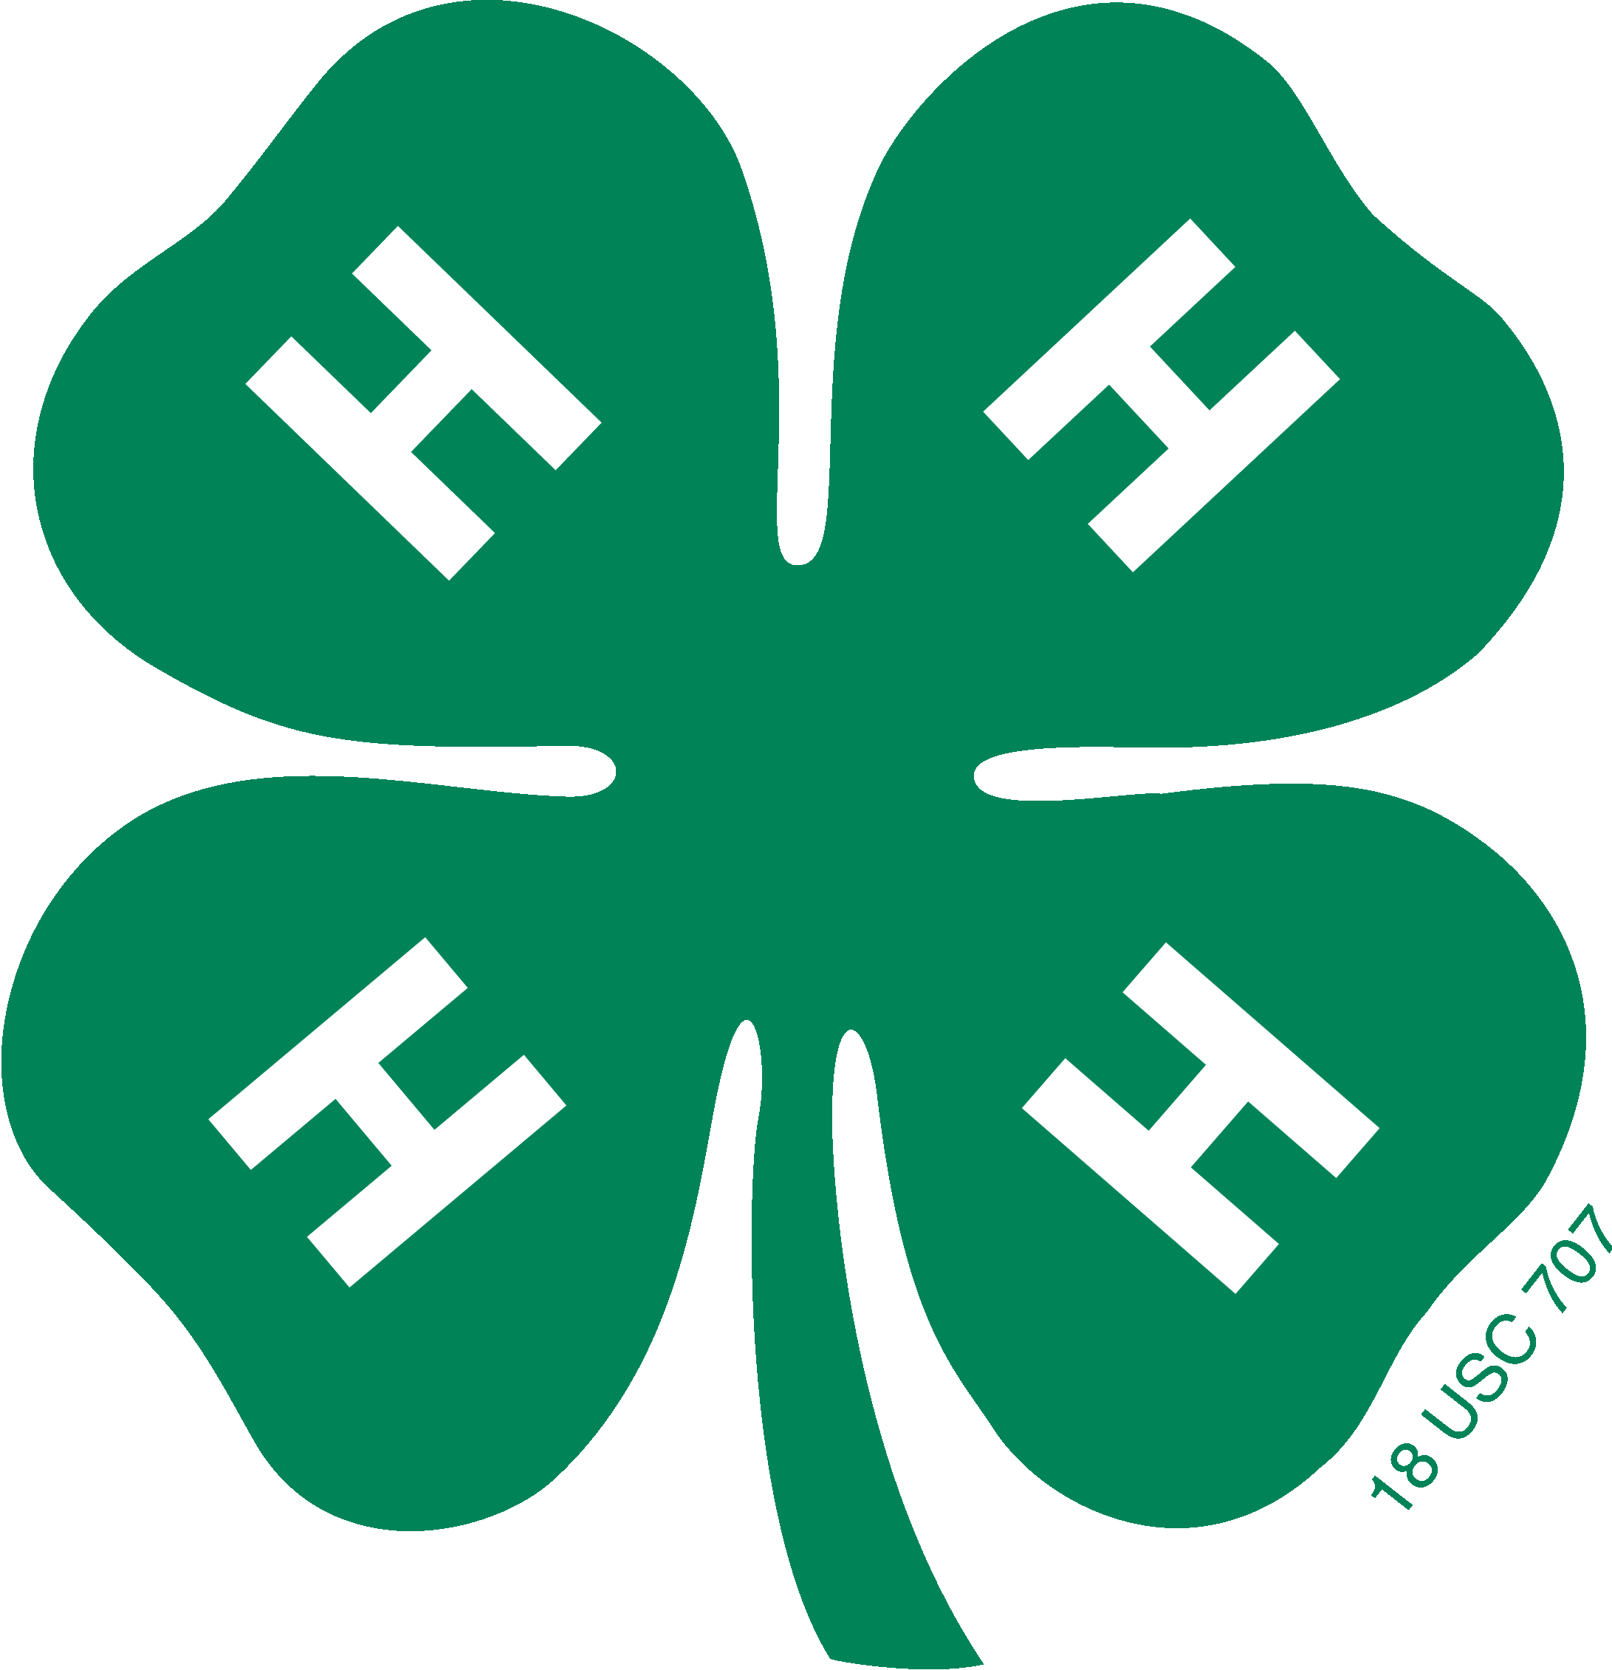
Sampson County 4-H
State Fair Youth Entry Guide

This form is to serve as a guide for youth and volunteers entering youth in the North Carolina 4-H Youth Exhibits and/or other exhibits at the North Carolina State Fair. You will find links within this document for the current year’s State Fair Catalog as soon as it made available to the public.

If you still have questions, contact information for both the State Fair staff and County 4-H Staff can be found on this guild.

- GETTING STARTED

To enter contest or competitions for the North Carolina State Fair, you are going to want to go to the North Carolina State Fair website. This site can be found easily by googling NC State Fair. You can also type in www.ncstatefair.org in your web browser. You will arrive at something that looks like this.

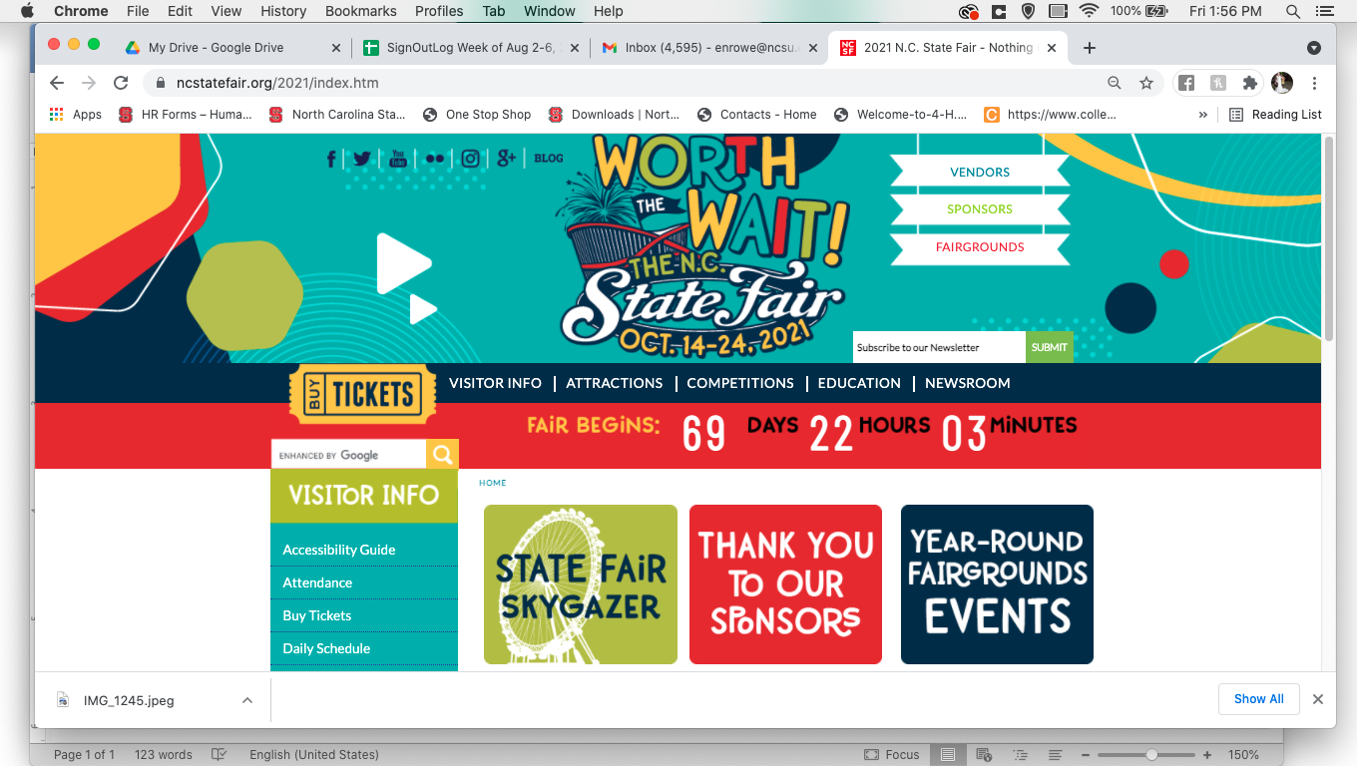

- GETTING TO THE COMPETITIONS PAGE

The next step is going to be finding the page to enter contest and competitions. This is easy to do from the main page. Just scroll to the tab labeled “Competitions” on the navy bar next to “Buy Tickets” and click. A menu should appear. Just select “Enter Competition”. This should take you to the competitions page.

Click here

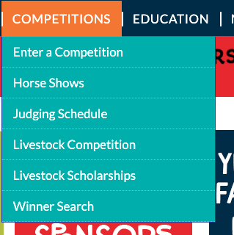
Click here if you wish to enter photography, crafts, 4-H Entomology, and other contest.

Click here if you wish to enter Youth Livestock Shows.

This tab will tell you all the information that you will need to know about when entries are due to NC State Fair grounds and when Judging of that particular contest will take place.

- ENTERING A CONTEST

After clicking the “Enter a Competition” tab, you will now find yourself on the Competitive Exhibits homepage. BE SURE TO READ THIS PAGE. READ ALL DIRECTIONS AND FOLLOW ALL GUILDLINES GIVEN BY THE NORTH CAROLINA STATE FAIR. Failure to do so could lead to disqualification or failure to receive your premiums.

YOUTH: You may need a parent or guardians help for this section. To enter a contest, the NC State Fair requires a social security number. This allows the NC State fair to send your prize money to you in the mail. If you do not supply a Social Security number, you will not receive you prize premiums and will forfeit your money.

You can find answers to other frequent asked questions on this page for all contest and livestock shows through their “GENERAL FAQS” or “LIVESTOCK FAQS” link.

At the bottom of this page you will find three colored bars. You are going to want to click the blue bar that reads “General Competitions”.
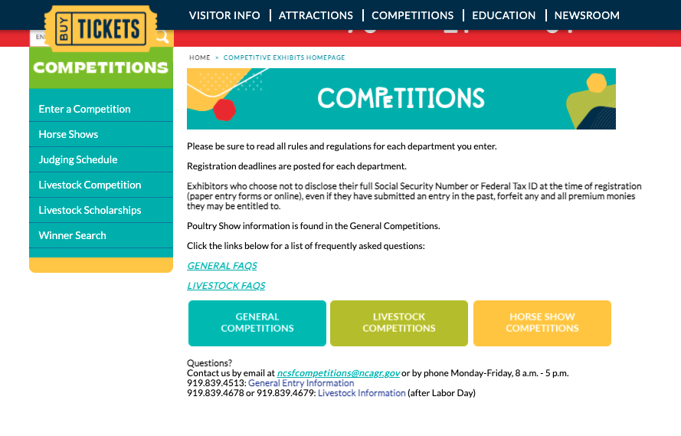

After selecting this block, you will find yourself on the follow page.
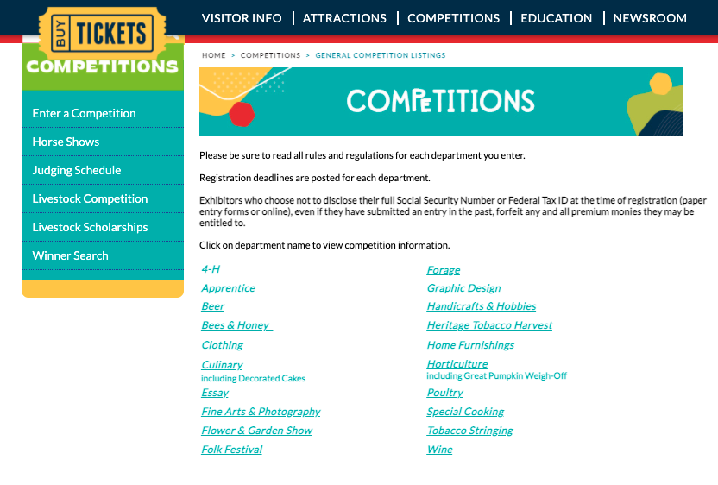

- ENTERING 4-H DIVISION

This is where common errors are made. Once you get to this page, the only competition you need to select is 4-H. DO NOT SELECT FROM ANY OF THE OTHER CHOICES. If you are unsure of what area to enter, please refer to the premium book at the bottom of the page, or click here.

DO NOT SELECT FROM ANY OF THE OTHER CHOICES UNLESS YOU PLAN TO COMPETE OUTSIDE OF THE 4-H EXHIBIT

Once you have selected the 4-H Division, this will lead you to the 4-H Youth Development Page. From this page you will be able to access the Blue Ribbon Fair online registration system, competition rules, and paper entry form. This page will give you all the information about the current year’s entry submission and release times. If you would like Sampson County 4-H Staff to deliver and pick-up your entries from the State Fair, please contact us at 910-592-7161.
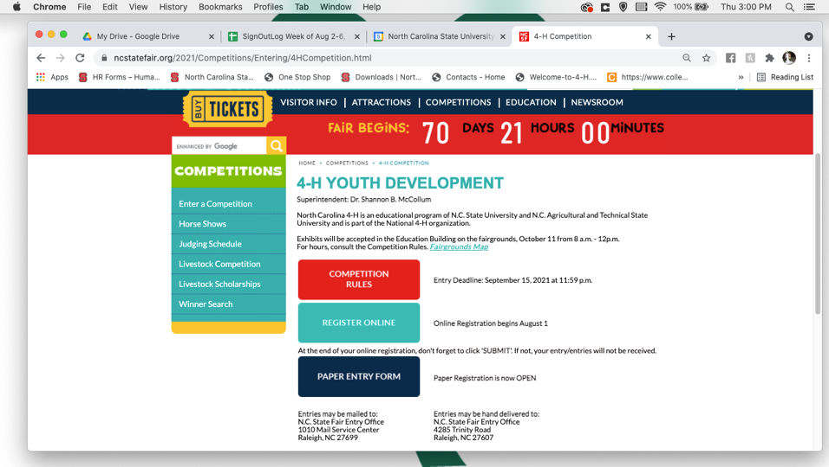

- MAKING A BLUE RIBBON FAIR PROFILE

Blue Ribbon is the online database that is used to collect NC State Fair entries every year. If you have participated in the past, you will need to create a new profile for each fair, seeing that the database “resets” every year and doesn’t store the previous years data.

To access Blue Ribbon Fair, just click “Register Online” on the 4-H Youth Development page under Competitions. Registration opens August 1 of the current year and runs until September. Best advice is to wait until later in the month to register for competitions. This allows the State Fair to work the IT “bugs” out of the website.

Click here to access Blue Ribbon

Once you have clicked on the Register button, you will be brought to a site that looks like this.
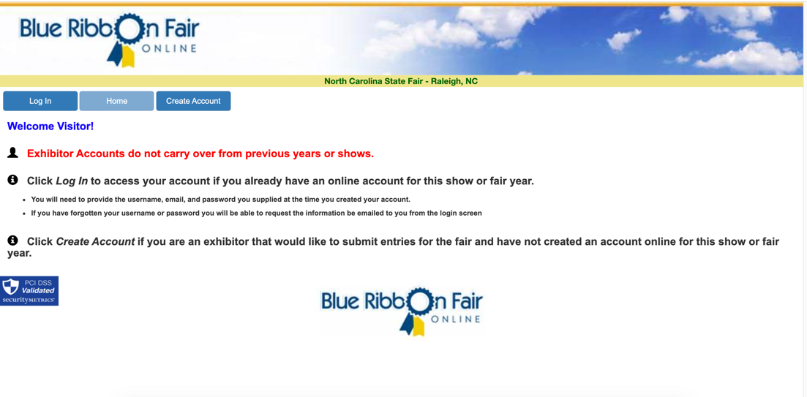

You will need to create a new account and follow the instructions. The instruction will be in purple text across the top of the screen. To enter 4-H, you will select Division II. All 4-H Competitions can be found under 4HY.
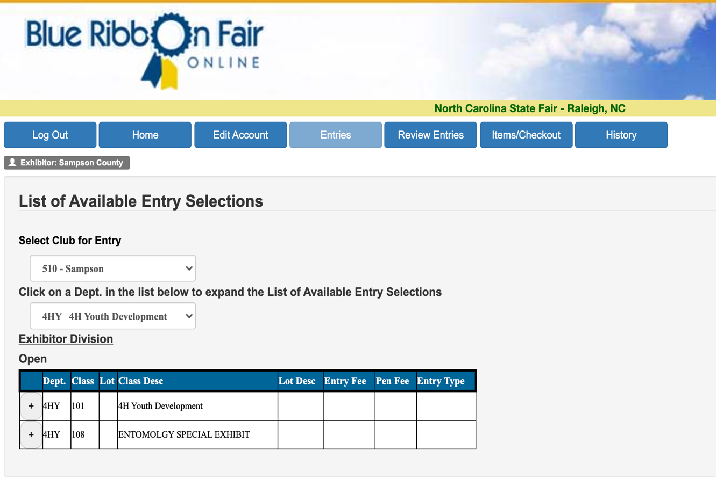

Your screen may look a little different from the one above. This is a screen shot of when we when were entering the County Hay Bale Decorating Contest. You will have a few more opinions to select from on your screen. Most of your choices will pop out when you click the plus sign located next to the 4-H Youth and Development tab.

After entering items, be sure to checkout and review your entries.

