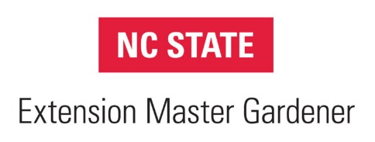
Training Syllabus

Instructor(s): Various
Contact: brad_hardison@ncsu.edu
Online: self-paced
Labs/trips: TBA
Program Purpose

The Master Gardener Volunteer Training Program prepares potential volunteers to assist North Carolina State Extension staff in addressing home horticulture-related topics, including plant selection, establishment and care of lawn, garden and landscapes with an emphasis on integrated approaches to pest management and environmental stewardship. Volunteers assist with Extension’s educational programs throughout Sampson County and extend the reach of horticulture extension staff by providing research-based information to home gardeners. Extension Master Gardeners Volunteers are a part of North Carolina State University, a land grant institution.

Extension Master Gardener Training is a 14-week course designed to enrich your horticultural knowledge so that you can become a better home gardener and provide non-biased, research-based information to residents of Sampson County. This course will cover importance of volunteerism, basic botany and entomology, vegetable/fruit production, as well as advanced topics such as IPM and landscape design. There will be a lab component and field trips with some classes. Field trips will be to areas outside, so please dress appropriately for the weather.

Course Objective:

The EMGV Training Program will equip trainees with the knowledge and skills necessary for addressing home horticulture-related topics. Upon completion of the training program, Master Gardener Volunteers will 1) assist horticulture staff in serving the residents of Sampson County in the field of consumer horticulture, and 2) Effectively deliver research-based information from NC State Extension and Horticulture Staff to the residents of Sampson County.

Class Schedule

Week 1 Class: Introduction to the Extension Master Gardener Volunteer (EMGV) Program and Orientation
Week 2 Class: Soils, Plant Nutrients, Fertilizers, and Composting (Chs. 1&2)
Lab: How to collect and box a soil sample

Week 3 Class: Basic Botany (Ch. 3);

Week 4 Class: Turf, Lawns and Weeds (Ch. 9&6)
Lab: Weed ID (Extension grounds)

Week 5 Class: Integrated Pest Management & Pollinators (Ch.8)
Lab: Pollinator garden tour

Week 6 Class: Vegetable, container, and raised bed gardening (Ch. 16)
Lab: 1) Parts of a seed; 2) Planting vegetables in containers

Week 7 Class: Small Fruits (Ch. 14)
Week 8 Class: Tree Fruits (Ch. 15)

Week 9 Class: Woody Ornamentals and Pruning (Ch. 11) Lab: Hands on Pruning
Week 10 Class: Herbaceous Ornamentals and Landscape Design (Ch. 10&19)
Week 11 Class: Insects (Ch. 4)

Week 12 Class: Disease and Disorders (Ch. 5)

Week 13 Class: Propagation (Ch. 13)
Lab: Hands on propagation (Extension greenhouse)

Week 14 Class: Native Plants & Wildlife (Ch. 12 & 20
Week 15 Class: Practical Exam

